“Medi-Search”

A Project Report Submitted in the partial fulfillment of the requirements for the award of the degree of

BACHELOR OF TECHNOLOGY

in

DEPARTMENT OF COMPUTER SCIENCE ENGINEERING

by

GURRALA JITHIN REDDY :2520030508

ADA ROHAN :2520030195

Under the Guidance of

Dr. V.Sireesha
Professor
Department of Computer Science and Engineering





2026-27

DEPARTMENT OF COMPUTER SCIENCE ENGINEERING

Declaration

The Project Report entitled “MEDISEARCH” is a record of Bonafide work of – GURRALA JITHIN REDDY 2520030508, ADA ROHAN – 2520030195, submitted in partial fulfillment for the award of B. Tech in Computer Science and Engineering. The results embodied in this report have not been copied from any other departments/University/Institute.

GURRALA JITHIN REDDY – 2520030508
ADA ROHAN – 2520030195

DEPARTMENT OF COMPUTER SCIENCE ENGINEERING

CERTIFICATE

This is certify that the mini project based report entitled “MEDISEARCH” is a bonafide work done and submitted by GURRALA JITHIN REDDY – 2520030195, ADA ROHAN– 2520030195, in partial fulfillment of the requirements for the award of the degree of BACHELOR OF TECHNOLOGY in Department of Computer Science Engineering, during the academic year 2026-27.

Signature of the Guide Signature of the HOD
(Dr. V.Sireesha)
ACKNOWLEDGEMENT

Description in Times New Roman font 12 size with two to three paragraphs thanking guide Dr. V. Sireesha , Professor, Dept. of CSE and Dr. P. Venkateswara Rao, Associate Professor, HOD CSE

GURRALA JITHIN REDDY – 2520030508
ADA ROHAN – 2520030195

Abstract

.
Abstract
MediSearch is an intelligent medical text-analysis and patient record retrieval system designed to demonstrate the practical application of advanced Data Structures and Algorithms in a real-world healthcare-oriented domain. The system enables users to search and analyze patient records using multiple algorithmic approaches, providing efficient retrieval of relevant medical information from a collection of textual patient records. The proposed system integrates advanced string-processing, dynamic programming, graph, and randomized algorithm techniques to address different classes of information-retrieval and computational problems.

The system supports exact pattern searching using Knuth-Morris-Pratt (KMP) and Rabin-Karp algorithms, multi-pattern searching using the Aho-Corasick algorithm, and fuzzy medical-term matching using the Wagner-Fischer Edit Distance algorithm. Suffix Array and Longest Common Prefix (LCP) techniques are incorporated for textual similarity analysis, while Dinic's Maximum Flow algorithm demonstrates capacity-constrained resource allocation problems. Miller-Rabin provides a randomized algorithm component for efficient primality testing of large integers. Each algorithm is mapped to a specific problem within the system so that its theoretical advantages, computational complexity, and practical behavior can be observed.

The application follows a layered architecture consisting of a web-based presentation layer, Java-based HTTP/API layer, service layer, algorithmic processing layer, and file-based data layer. The frontend is implemented using HTML, CSS, and JavaScript, while the backend uses Java and manually implemented algorithms without relying on external algorithm libraries. This design emphasizes understanding and implementation of the underlying algorithms rather than abstraction through third-party frameworks.

The project demonstrates how advanced algorithmic techniques can be integrated into a single practical system while highlighting their respective time and space complexities, advantages, and limitations. MediSearch therefore serves both as a functional patient-record retrieval application and as an educational platform for understanding advanced string algorithms, dynamic programming, network flow, randomized algorithms, and algorithmic problem-solving.

Table of Contents

 |  |  | Page No.
 | Acknowledgement
 | Abstract
 | Table of Contents
 | List of Figures
1 | Introduction | 1.1 Overview  1.2 Problem statement  1.3 Scope of the project  1.4 Objectives | 5-15
2 | System Requirements | 2.1 Functional Requirements  2.2 Non-Functional Requirements | 16-21
3 | System Design | 3.1 High-level Architecture Diagram  3.2 Description of each layer | 33-36
4 | Implementation | 4.1 Module-wise implementation  4.2 Front-end logic (UI rendering, state management)  4.3 API integration  4.4 ……. | 38-47
5 | Results |  | 56-64
6 | Challenges & Limitations | 6.1 Issues faced during development  6.2 Solutions applied  6.3 Limitations of the System | 74-82
7 | Conclusion & Future Work | 7.1 Conclusion  7.2 Future Work  7.3 Skills learned during development | 89-97
8* | References | - Books, tutorials, APIs, documentation sites used | 98-99

List of Figures

1.1 Block Diagram of a Recommendation System 3
1.2 Components of a Recommendation System 6
1.3 Flow Chart to show the working of a Recommendation System 7
1.4 Phases of a Recommendation System 8
1.5 User-User KNN based Recommendation System 13
1.6 Item-Item KNN based Recommendation System 14
1.7 Matrix Factorization based Recommendation System 40

- INTRODUCTION

1.1 Overview
MediSearch is an intelligent medical text-analysis and patient record retrieval system designed to help users efficiently search and analyze textual patient records containing symptoms, diagnoses, medications, and medical history.
The system applies advanced Data Structures and Algorithms to solve different search and analysis problems. It incorporates algorithms such as KMP, Rabin-Karp, Aho-Corasick, Edit Distance, Suffix Array with LCP, Dinic's Maximum Flow, and Miller-Rabin for pattern matching, fuzzy searching, similarity analysis, flow-based allocation, and randomized computation.
MediSearch uses a web-based frontend with a Java backend and a modular algorithm layer. The project focuses on connecting theoretical algorithmic concepts with practical applications while analyzing their efficiency, time complexity, and suitability for different types of problems.

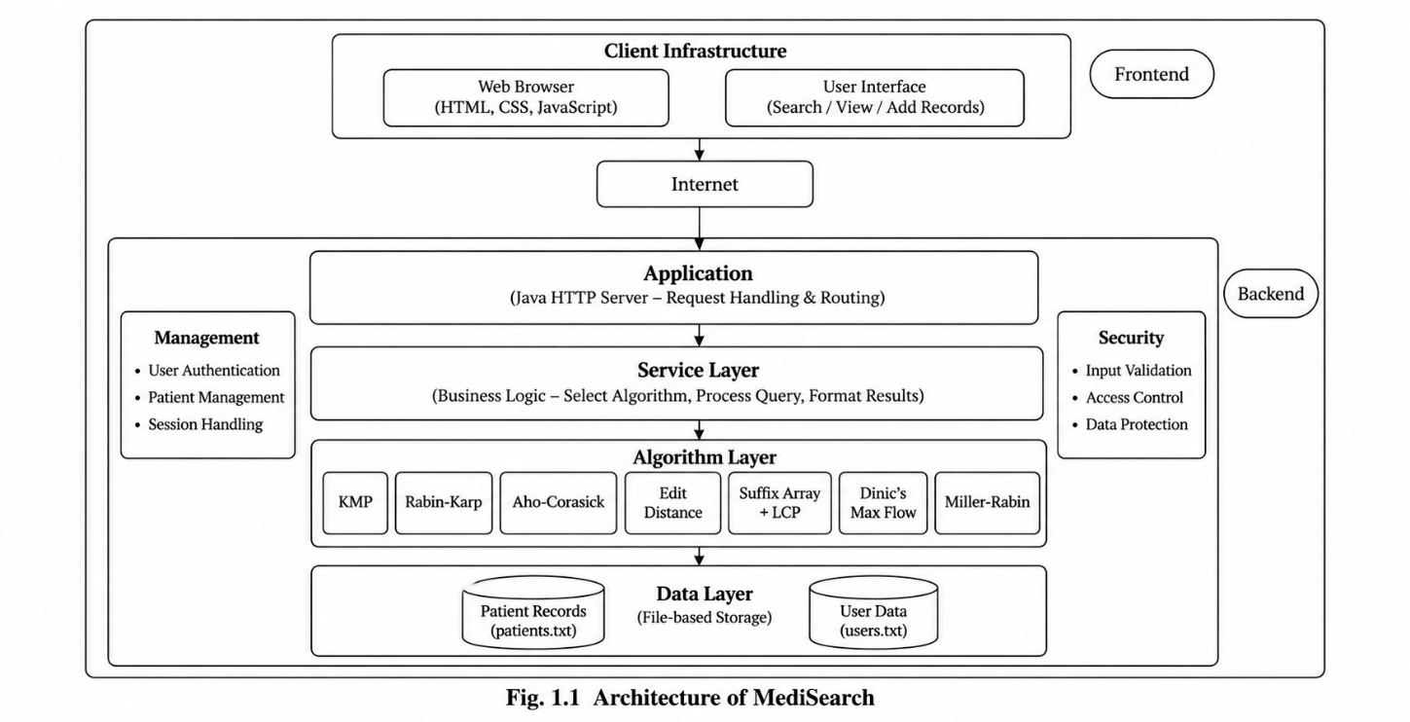
Fig. 1.1 Architecture of Cloud

1.2 Problem Statement
Doctors and healthcare professionals may need to search through a large number of patient records to find information related to specific symptoms, diagnoses, medical conditions, or previous treatments. A simple search method may fail when the search term contains spelling mistakes, different word forms, or information that is similar but not exactly identical.
For example, searching for "diabtes" may not produce the expected result if the stored record contains "diabetes". Similarly, two patients may have different descriptions of symptoms but still have medically similar information.
Therefore, there is a need for a patient search application that can:
- Quickly search patient records for specific patterns.
- Handle spelling mistakes and minor variations in search terms.
- Find records containing similar information.
- Efficiently process user-provided patient data.
- Demonstrate the practical application of DSA techniques.
MediSearch addresses these problems by integrating pattern searching, fuzzy matching using Edit Distance, and document similarity techniques into a single patient retrieval application.

Scope of the Project
The scope of MediSearch is to develop a DSA-based medical information retrieval and text-analysis application that can efficiently search, compare, and analyze patient records using advanced algorithms.
The project includes the following areas:
- Patient Data Management
The application manages patient information such as Patient ID, symptoms, diagnosis, medical history, medications, and treatment details.
- Pattern Searching
String-matching algorithms such as Knuth-Morris-Pratt (KMP), Rabin-Karp, and Aho-Corasick are used for efficient single-pattern and multi-pattern searching within patient records.
- Fuzzy Matching
Edit Distance (Wagner-Fischer) is used to identify terms that are similar to the user's input, helping handle spelling mistakes and variations in medical terminology.
- Document Similarity
Suffix Array and LCP techniques are used to analyze textual similarity between patient records and identify potentially related medical cases.
- Graph-Based Analysis
Dinic's Maximum Flow algorithm is included to demonstrate capacity-constrained resource allocation and related graph-based optimization problems.
- Randomized Algorithm Demonstration
Miller-Rabin is used to demonstrate efficient probabilistic primality testing of large integers as part of the project's randomized algorithm component.
- DSA Demonstration and Analysis
The system demonstrates the practical application of advanced algorithms while allowing their time complexity, space complexity, and suitability for different problems to be studied.
Project Limitations
The project is intended primarily as an academic DSA application and is not designed to provide medical diagnosis, treatment recommendations, or clinical decision-making. Its primary purpose is medical information retrieval, text analysis, and demonstration of advanced algorithms in a practical application

Objectives
The main objectives of the MediSearch project are:
- To develop a patient information retrieval application using advanced Data Structures and Algorithms.
- To implement efficient pattern searching for finding specific medical terms within patient records.
- To implement KMP, Rabin-Karp, and Aho-Corasick algorithms for efficient single-pattern and multi-pattern string searching.
- To implement Edit Distance for fuzzy matching and handling spelling errors and variations in medical search queries.
- To identify similar patient records using Suffix Array and LCP-based text similarity techniques.
- To demonstrate Dinic's Maximum Flow for solving capacity-based resource allocation problems.
- To demonstrate Miller-Rabin as a randomized algorithm for efficient primality testing of large integers.
- To improve search efficiency compared with simple sequential keyword matching.
- To allow users to enter and search their own patient data instead of depending only on predefined records.
- To demonstrate the practical application of advanced DSA concepts in a healthcare-related scenario.
- To retrieve relevant patient information efficiently and accurately based on user queries.
- To provide a foundation for a scalable patient-record search system that can be extended with additional algorithms and data structures in the future

- T. H. Cormen, C. E. Leiserson, R. L. Rivest, and C. Stein, Introduction to Algorithms, 4th ed. Cambridge, MA, USA: MIT Press, 2022. MIT Press
- J. Kleinberg and É. Tardos, Algorithm Design. Boston, MA, USA: Pearson, 2005. Pearson
- J. Erickson, Algorithms. Independently published, 2019.
- A. V. Aho and M. J. Corasick, “Efficient string matching,” Communications of the ACM, vol. 18, no. 6, pp. 333–340, 1975. Bishtref
- Java Platform Documentation, “Java SE Documentation,” Oracle. [Online]. Available: Java Documentation
- MDN Web Docs, “HTML, CSS, and JavaScript Documentation,” Mozilla. [Online]. Available: MDN Web Docs
- OpenJDK, “Java Platform, Standard Edition Documentation.” [Online]. Available: OpenJDK Documentation

2. SYSTEM REQUIREMENTS

2.1 Functional Requirements
The functional requirements of MediSearch define the operations and services that the system is expected to provide.
- User Authentication
The system shall allow users to log in using valid credentials before accessing protected patient-related features.
- Patient Data Management
The system shall allow patient records containing details such as patient ID, symptoms, diagnosis, medical history, medications, and treatment information to be stored and retrieved.
- Exact Pattern Searching
The system shall provide exact medical-term searching using string-matching algorithms such as KMP and Rabin-Karp.
- Multi-Pattern Searching
The system shall support simultaneous searching for multiple symptoms or medical keywords using the Aho-Corasick algorithm.
- Fuzzy Matching
The system shall identify records containing terms that are similar to a user's input using Edit Distance.
- Document Similarity
The system shall compare textual patient records and identify potentially similar medical cases using Suffix Array and LCP-based techniques.
- Resource Allocation
The system shall provide a graph-based demonstration of capacity-constrained resource allocation using Dinic's Maximum Flow algorithm.
- Primality Testing
The system shall provide a demonstration of large-integer primality testing using the Miller-Rabin randomized algorithm.
- Patient Record Retrieval
The system shall display relevant patient records based on the user's search query.
- Patient Record Listing
The system shall provide an option to view available patient records.
- Patient Record Addition
Authorized users shall be able to add new patient records to the system.

2.2 Non-Functional Requirements
- Performance
The system should provide efficient search and analysis for the intended patient-record dataset.
- Scalability
The architecture should allow additional patient records, algorithms, and search features to be incorporated in the future.
- Usability
The interface should provide simple controls for entering search queries and viewing results.
- Reliability
Invalid inputs and unexpected requests should be handled without causing the complete application to terminate.
- Maintainability
The system should maintain a clear separation between the frontend, API layer, service layer, algorithms, and data storage.
- Portability
The application should be capable of running in a standard Java environment without requiring a complex application framework.
- Security
User authentication and patient information should be protected from unauthorized access.
- Extensibility
The algorithm layer should allow additional algorithms and data structures to be incorporated without major changes to other system components.

2. SYSTEM DESIGN
The system design of MediSearch defines the overall structure of the application and explains how the frontend, backend, service modules, algorithmic components, and data storage interact with one another. The architecture is designed to keep the user interface, application logic, DSA implementations, and data management logically separated.
The proposed design also allows different algorithms to be applied according to the type of operation requested by the user. This makes the system suitable not only for patient-record retrieval but also for demonstrating the practical use of advanced algorithms in string processing, dynamic programming, graph algorithms, and randomized computation.

3.1 High-Level Architecture Diagram
Fig. 1.1 Architecture of MediSearch
The architecture follows a layered approach. A user's request begins at the presentation layer and is transmitted to the Java backend through HTTP. The API layer routes the request to the appropriate service, which validates the input and invokes the required algorithm or data-management operation. The result is then returned through the same layers and displayed to the user.
The current repository already follows the basic principle of separating the HTTP server, service classes, algorithm implementation, models, and file-based storage. The existing implementation contains Main.java, MediSearchService, PatientFileService, UserFileService, Patient, User, and AhoCorasick. codebase_audit The expanded architecture extends this foundation to accommodate the additional algorithms planned for the project.

3.2 Description of Each Layer

3.2.1 Frontend Layer
The presentation layer is the user-facing part of MediSearch. It is implemented using HTML, CSS, and JavaScript.
The layer provides the interface through which users can:
- Log into the system.
- View patient records.
- Enter medical search queries.
- Select different search and analysis operations.
- Submit patient information.
- View retrieved records.
- View algorithm-generated results.
- Observe errors and status messages.
JavaScript manages user interactions and communicates with the backend using HTTP requests. The results returned by the backend are then dynamically displayed on the webpage.
The presentation layer does not directly implement the DSA algorithms. Instead, it collects the required input and sends it to the appropriate backend service.

3.2.2 API / Application Layer
The API layer acts as the communication bridge between the frontend and backend.
The backend is implemented using Java's lightweight HTTP server. In the existing implementation, Main.java acts as the primary server entry point and contains handlers for operations such as login, logout, sessions, patients, searching, and static files. codebase_audit
The API layer is responsible for:
- Receiving HTTP requests.
- Identifying the requested operation.
- Reading request parameters or request bodies.
- Performing basic validation.
- Calling the appropriate service method.
- Formatting the result.
- Returning the response to the frontend.
The API layer therefore prevents the frontend from directly accessing the algorithm or storage implementations.
3.2.3 Service Layer
The service layer contains the primary application logic.
The major responsibilities include:
- Patient record management.
- Search request processing.
- Keyword validation and sanitization.
- Authentication-related operations.
- Selection and invocation of algorithms.
- Coordination between algorithms and patient data.
- Preparation of results for the API layer.
The existing MediSearchService already performs keyword sanitization, creates the Aho-Corasick search structure, searches patient records, and collects matching results. codebase_audit
In the expanded system, the service layer will determine which algorithm should be used according to the requested operation.
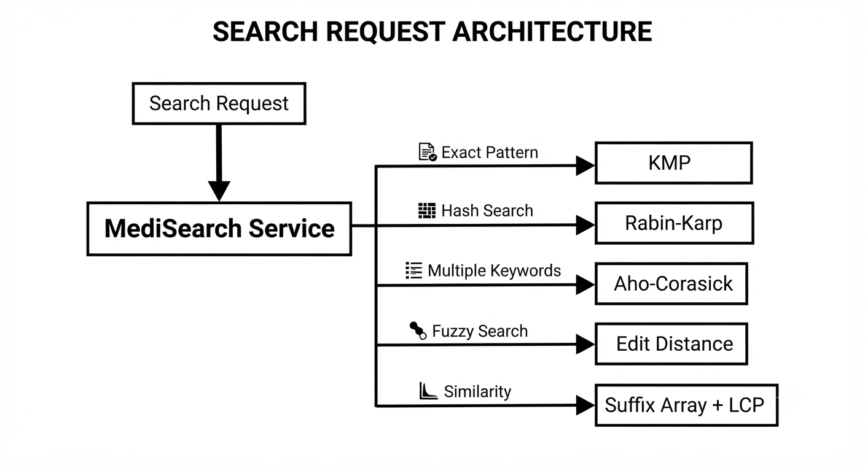
3.2.4 Algorithm Layer
The algorithm layer is the core DSA component of MediSearch.
Each algorithm is implemented as an independent module so that its logic can be developed, tested, and analyzed separately from the application and user-interface code.
The proposed algorithmic components are:
A. KMP
The Knuth-Morris-Pratt algorithm performs exact pattern matching by preprocessing the pattern and constructing an LPS array. It avoids unnecessary comparisons when a mismatch occurs.
Application: Exact medical-term searching.
B. Rabin-Karp
Rabin-Karp uses polynomial hashing and a rolling hash to locate candidate occurrences of a pattern.
Application: Hash-based medical-term searching and algorithm comparison.
C. Aho-Corasick
Aho-Corasick constructs a Trie of multiple patterns and adds failure links to support simultaneous pattern matching.
Application: Searching multiple symptoms or medical terms within patient records.
The existing implementation already uses a Trie transition structure, failure links, BFS construction, and an output bitmask. codebase_audit

D. Edit Distance
The Wagner-Fischer dynamic-programming algorithm calculates the minimum number of insertions, deletions, and substitutions required to transform one string into another.
Application: Fuzzy medical-term and diagnosis matching.
E. Suffix Array and LCP
A suffix array organizes suffixes of a text in lexicographical order, while the LCP array stores the longest common prefixes between adjacent suffixes.
Application: Identifying common textual patterns and supporting patient-record similarity analysis.
F. Dinic's Maximum Flow
Dinic's algorithm solves maximum-flow problems using a residual network, BFS-generated level graphs, and blocking flows.
Application: Demonstrating capacity-constrained resource allocation within a healthcare-oriented scenario.
G. Miller-Rabin
Miller-Rabin is a probabilistic primality-testing algorithm based on modular arithmetic and witness testing.
Application: Demonstrating randomized algorithms and large-integer primality testing.
3.2.5 Data Layer
The data layer manages persistent application information.
The current system uses local file-based storage rather than a relational or NoSQL database. Patient records and user information are maintained separately. The PatientFileService handles patient file operations, while UserFileService manages user-related storage. codebase_audit
The data layer performs operations such as:
- Loading patient records.
- Creating patient records.
- Reading user information.
- Storing updated information.
- Parsing stored records.
- Providing data to the service layer.
The separation of this layer means that the algorithm modules do not need to know how patient records are physically stored.
3.3 Data Flow Architecture
The general data flow of MediSearch is:
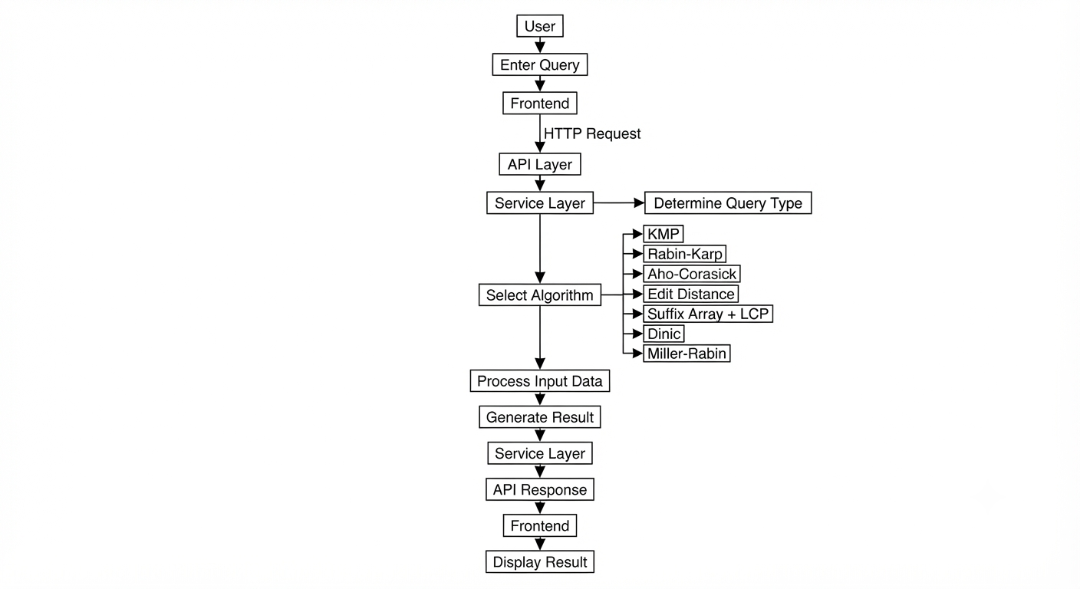
This flow ensures that the user interface remains independent of the internal implementation of individual algorithms.

3.4 Algorithm Selection Architecture
A major design feature of the proposed MediSearch system is that different algorithms are used for different computational requirements.
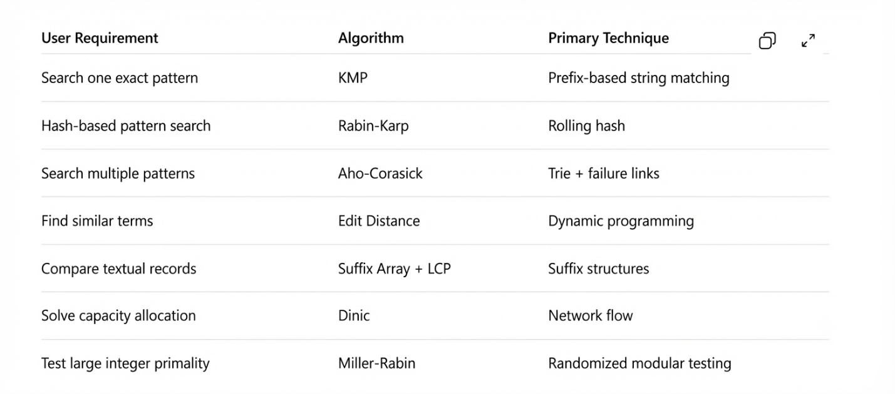

3.5 Component Interaction
The main components interact as follows:

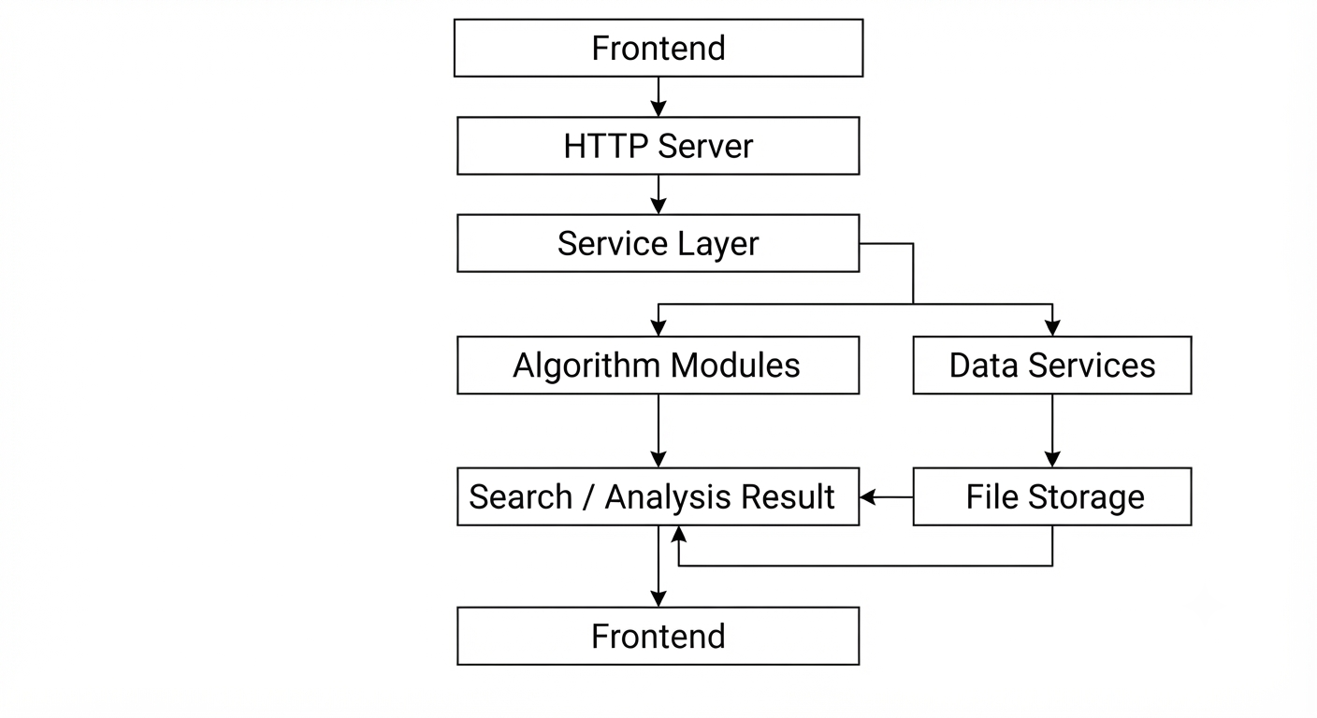

3.6 Data Storage Design
The current system uses file-based persistence.
A simplified structure is:
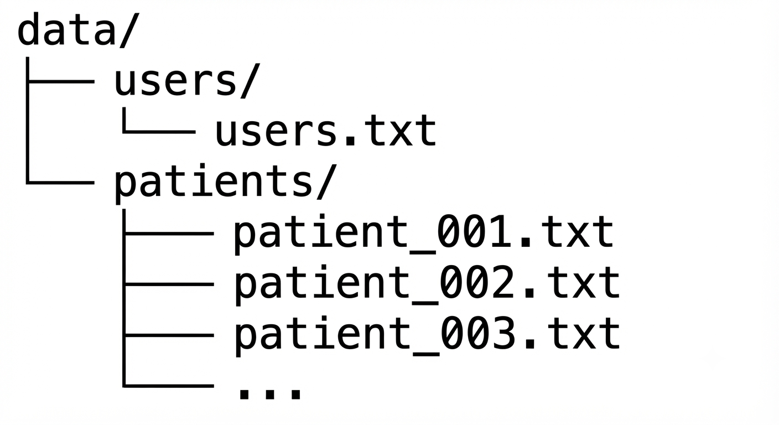

Patient records are loaded by the patient file service and converted into Patient objects. The resulting patient information can then be transformed into searchable text for algorithmic processing.
The current Patient model also provides a method for creating a combined textual representation of the record, which is used by the search process. codebase_audit.

3.7 Security and Session Architecture
The system includes an authentication mechanism in which users provide login credentials through the frontend. The backend validates the credentials and maintains active sessions.
The existing architecture stores active session tokens in memory within the server. codebase_audit
For the expanded system, authentication remains separate from the algorithmic layer. Search algorithms operate on authorized requests and do not directly manage user authentication.

3.8 Design Principles
The MediSearch architecture follows several important design principles:
Modularity
Each algorithm and major application function is maintained as a separate module.
Separation of Concerns
The frontend, API handling, business logic, algorithms, and storage responsibilities are separated.
Reusability
Algorithm implementations can be invoked by different services without duplicating their logic.
Extensibility
New algorithms can be added to the algorithm layer without requiring major changes to the frontend or data-storage components.
Testability
Individual algorithms can be tested independently using predefined inputs before being integrated with the complete application.
Algorithmic Transparency
The system is designed so that the algorithms are implemented directly rather than hidden behind external DSA libraries. This is particularly important because the project is intended to demonstrate understanding of advanced DSA concepts.

3.9 Overall System Workflow
The complete system workflow can be summarized as:
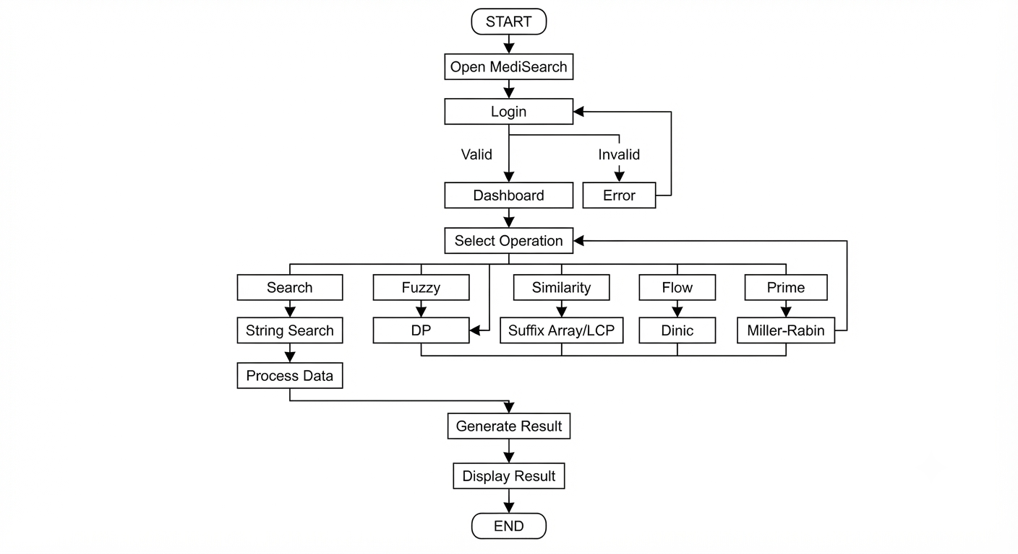

4. IMPLEMENTATION
This section describes the implementation of MediSearch, including the backend modules, patient-data processing, DSA components, frontend logic, API communication, and data storage. The implementation is organized so that the user interface communicates with the Java backend through HTTP, while the service layer coordinates patient-data operations and algorithm execution.
Important: The current repository already implements the Java HTTP server, patient/user services, file-based storage, frontend, and Aho-Corasick search. The other algorithms discussed in the expanded project scope are planned implementation modules and should not be presented as already implemented until we add and test them. The existing audit confirms that Aho-Corasick is currently the only algorithm present in the repository.

4.1 Module-Wise Implementation
4.1.1 Server Module
The server module is implemented through Main.java, which acts as the entry point of the Java application. It creates and starts the HTTP server and handles incoming requests from the frontend.
The server contains handlers for the major application operations, including:
- Login
- Logout
- Session handling
- Patient retrieval
- Patient creation
- Search requests
- Static frontend-file delivery
The server uses Java's built-in HTTP server rather than a framework such as Spring Boot. This keeps the backend lightweight and allows the project to focus on the implementation of the DSA components.

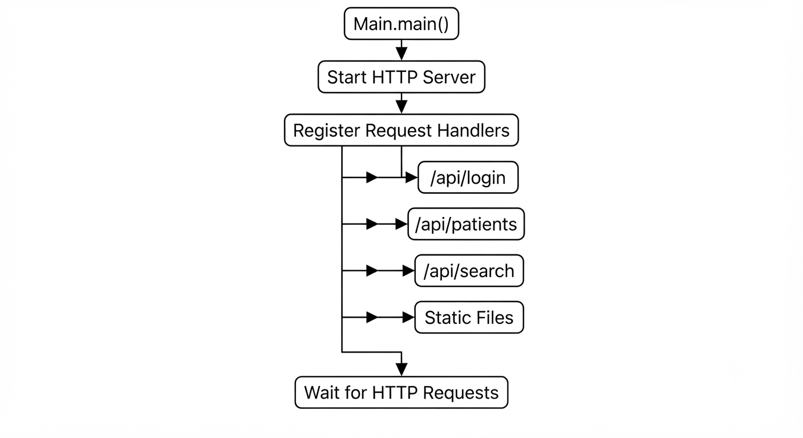

4.1.2 Patient Model Module
The Patient class represents an individual patient record.
The model contains the information required by the application and provides methods for converting the record into formats required by other modules.
One particularly important operation is the generation of a combined textual representation of the patient's information. This representation allows the DSA search engine to treat the complete patient record as searchable text.
The patient model therefore acts as the connection between structured medical information and the string-processing algorithms

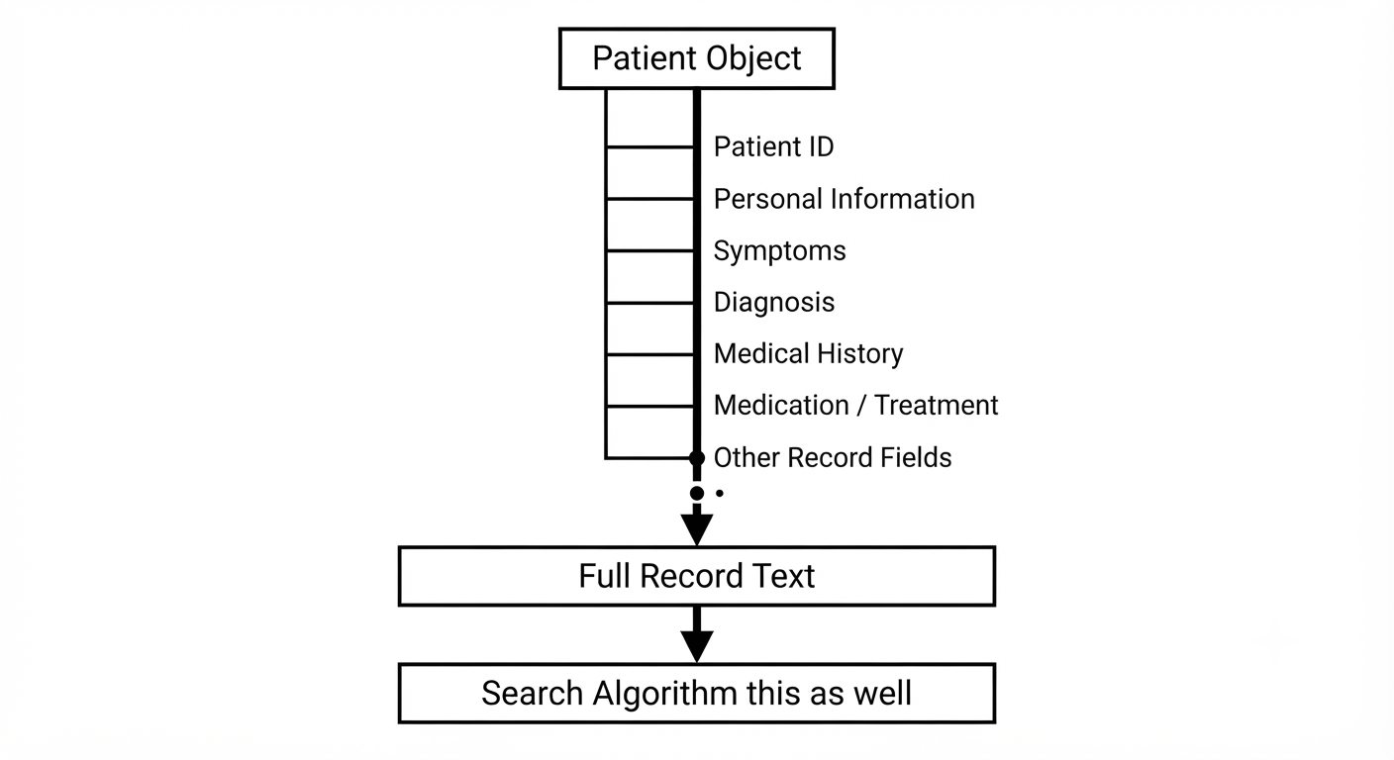

4.1.3 Patient File Service
PatientFileService is responsible for persistence and retrieval of patient records.
Instead of using a database, the current implementation stores individual patient records as local files. The service handles operations such as:
- Loading all patients
- Parsing patient files
- Saving new patients
- Generating patient IDs
The basic processing flow is:
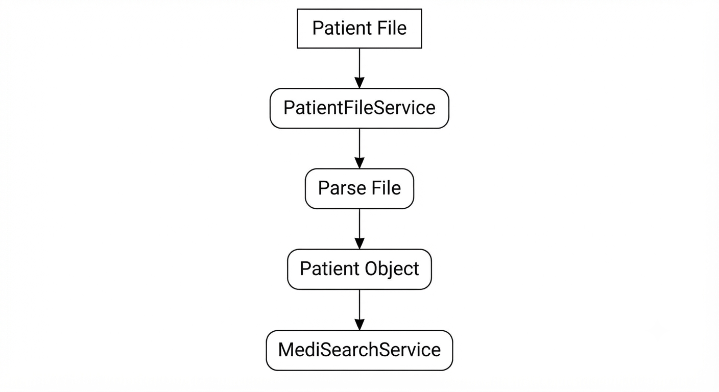

This makes the data layer independent of the search algorithms. The algorithms receive patient text rather than directly opening files.
The current audit identifies loadAllPatients, parsePatientFile, savePatient, and generateNextPatientId as important operations of this service. codebase_audit.

4.1.4 User and Authentication Module
The authentication functionality is divided between User, UserFileService, and the authentication handlers in Main.java.
The User model represents authentication-related information. Password processing uses SHA-256 hashing through Java's MessageDigest.
The login process is:
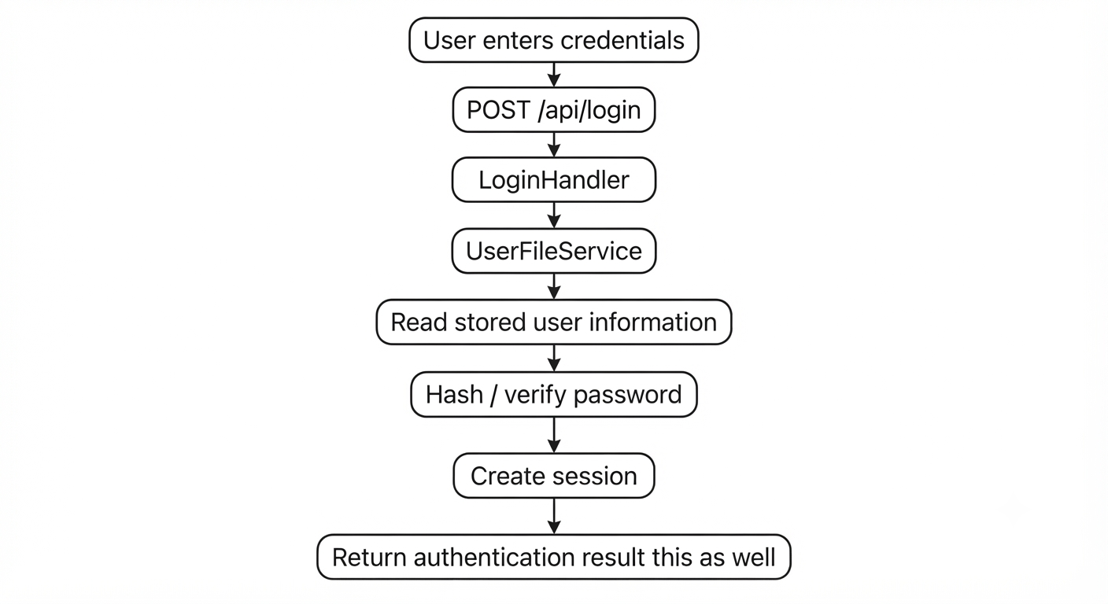

4.1.5 Search Service Module
MediSearchService is the central business-logic component for patient searching.
The current search process performs the following operations:
- Receives the search keywords.
- Sanitizes the input.
- Removes duplicate keywords.
- Creates an Aho-Corasick matching machine.
- Loads patient records.
- Searches each patient's textual record.
- Collects matching keywords.
- Produces search results for the API layer.
The existing implementation uses a LinkedHashSet during keyword sanitization to remove duplicates while preserving order. codebase_audit
The actual current search flow is:
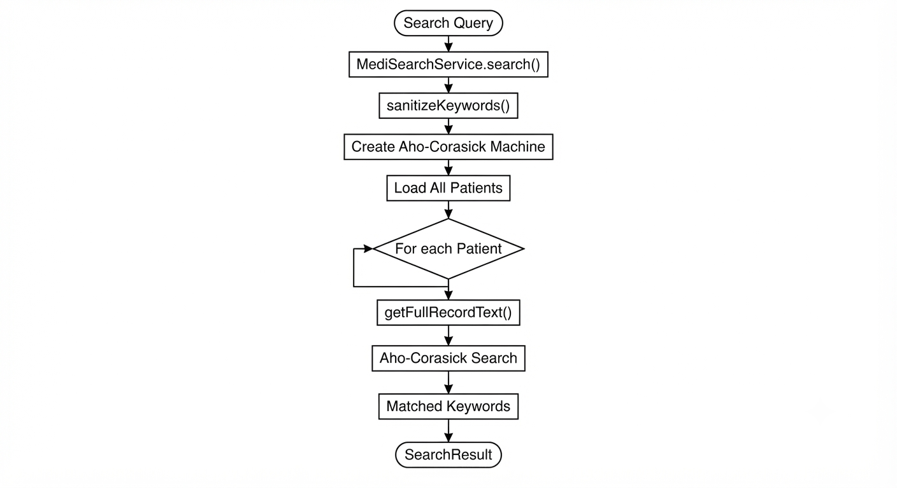

4.1.6 Aho-Corasick Module
The current repository's main DSA implementation is AhoCorasick.java.
The implementation uses:
- Trie transitions
- Failure links
- BFS
- Output bitmask
- Queue-based state processing
The implementation represents the transition structure using the g array, failure links using f, and matched patterns using out. codebase_audit
Construction
The algorithm first inserts each search keyword into the Trie.
For example, given:
fever
fee

The implementation then constructs failure links using BFS.
Searching
Once the automaton has been constructed, the patient's record is scanned from left to right.
When the next character exists in the current state, the automaton follows the transition.
When it does not exist, the algorithm follows failure links until an appropriate transition is found.
This allows multiple patterns to be searched during one traversal of the text. codebase_audit
Current Implementation Constraint
The implementation uses a 32-bit integer output mask. Consequently, the output representation is limited to 32 keyword positions. The Trie transition/state structure is also statically allocated with a maximum of 1000 states. codebase_audit
These limitations will be addressed when we redesign the algorithm module.

4.1.7 Planned KMP Module
Status: Planned — not currently present in the repository.
KMP will be added as an independent algorithm module for exact single-pattern searching.
The implementation will contain:
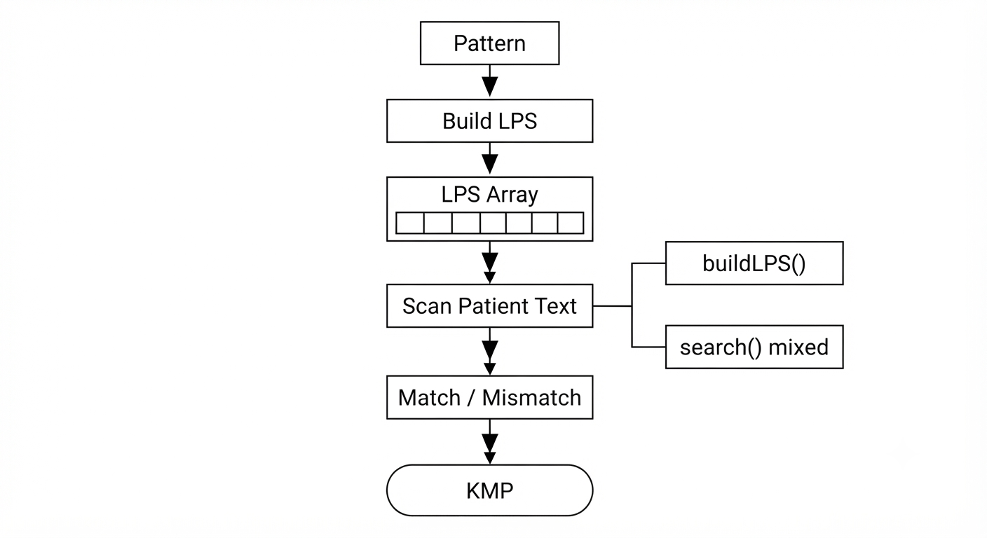

After the search operation is completed, the matching patient records are stored as SearchResult objects. Each result contains the corresponding patient information and the keywords matched in the patient record.
The results are then converted into JSON format and sent to the frontend through the search API. The frontend displays the matching patient records along with the relevant matched keywords.
This approach separates search processing from result presentation, making the system easier to maintain and extend.
now next let's complete ASAP
4.2 Front-End Logic
The frontend of MediSearch is implemented using HTML, CSS, and JavaScript. It provides the interface for user login, patient record management, and searching patient information.
4.2.1 UI Rendering
JavaScript dynamically updates the webpage based on user actions. Search results received from the backend are displayed as patient records, including the patient details and matched keywords.
4.2.2 State Management
The frontend maintains basic application state such as the current login status, search input, and retrieved patient results. This allows the interface to update without unnecessary page reloads.
4.2.3 User Interaction
Users can enter search keywords, submit requests, view matching patient records, and interact with the available patient-management features through the web interface.

4.3 API Integration
The frontend communicates with the Java backend through HTTP API endpoints.
API Endpoint | Purpose
/api/login | Authenticates the user
/api/patients | Retrieves patient information
/api/search | Searches patient records
The frontend sends requests using JavaScript and processes the JSON responses returned by the backend. This separates the user interface from the application logic and allows the backend algorithms to operate independently of the frontend.

4.4 Data Processing Flow
The basic processing flow of MediSearch is:
User Input → Frontend → HTTP API → Service Layer → Aho-Corasick Search → Patient Records → Search Results → Frontend
The search service processes the entered keywords and compares them against patient records. Matching records are returned to the frontend for display.

4.5 Error Handling
The system performs basic validation during login, patient operations, and search requests. Invalid requests, missing patient records, and unsuccessful authentication are handled by the backend and reported to the frontend.

4.6 Implementation Summary
The implementation follows a simple layered structure where the frontend handles user interaction, the Java backend manages requests and application logic, and the algorithm layer performs patient-record searching. The current implementation uses Aho-Corasick for multi-keyword searching, with patient and user data stored using file-based services.

5. Results
5.1 Functional Results
The developed MediSearch system provides a web-based interface for accessing and searching patient records. The implemented system successfully integrates the frontend with the Java backend and provides the following functionality:
- User login and authentication
- Patient record retrieval
- Patient record management
- Keyword-based patient record search
- Display of matching patient records
- Display of matched keywords in search results
The backend currently uses file-based storage for patient and user information, while the search functionality is implemented using the Aho-Corasick algorithm. codebase_audit codebase_audit

5.2 Search Results
The main result of the system is the retrieval of patient records based on user-provided keywords.
For example, if the user searches for multiple medical terms such as “fever”, “cough”, and “headache”, the system processes the keywords and identifies patient records containing the matching terms.
The search service removes duplicate keywords, constructs the Aho-Corasick automaton, searches the patient records, and returns the matching patients with their matched keywords. codebase_audit

5.1 User Interface Results
The frontend provides the user with a simple interface for interacting with the system.
The following screenshots should be included:
Figure 5.1: Login Page
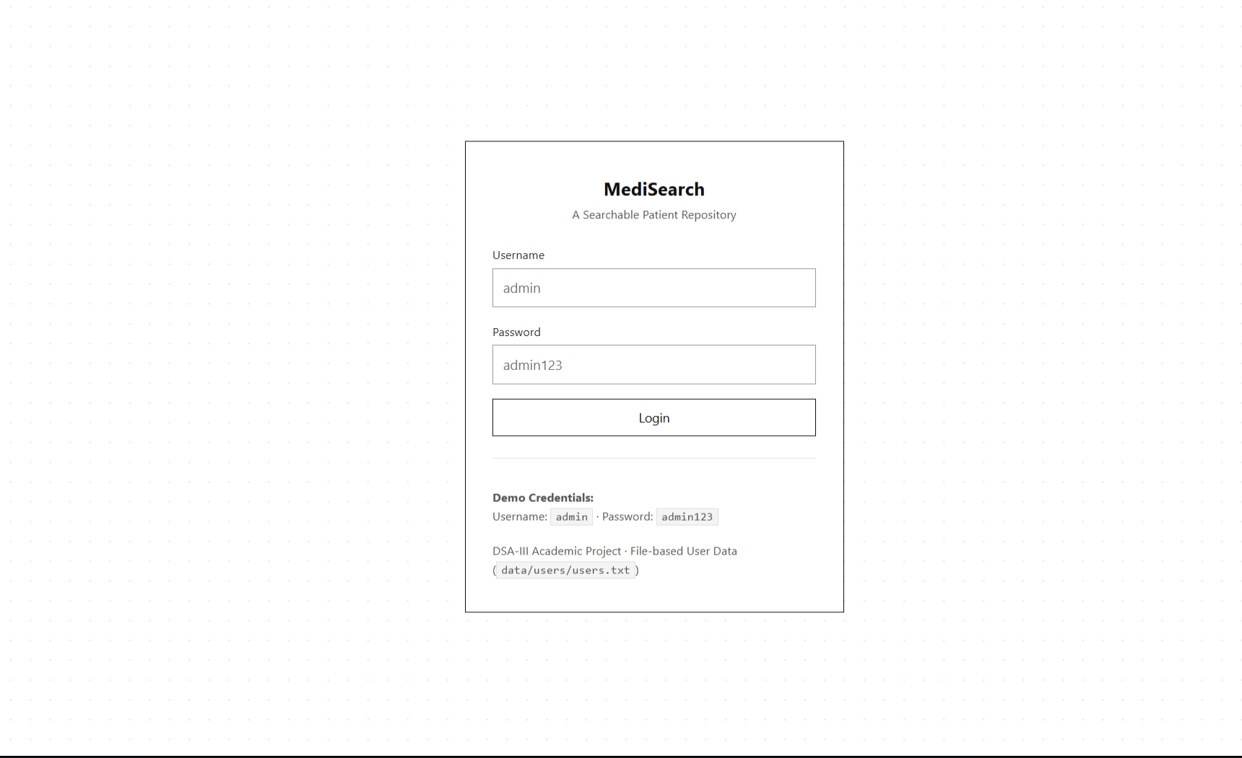
Figure 5.2 Patient Records Page
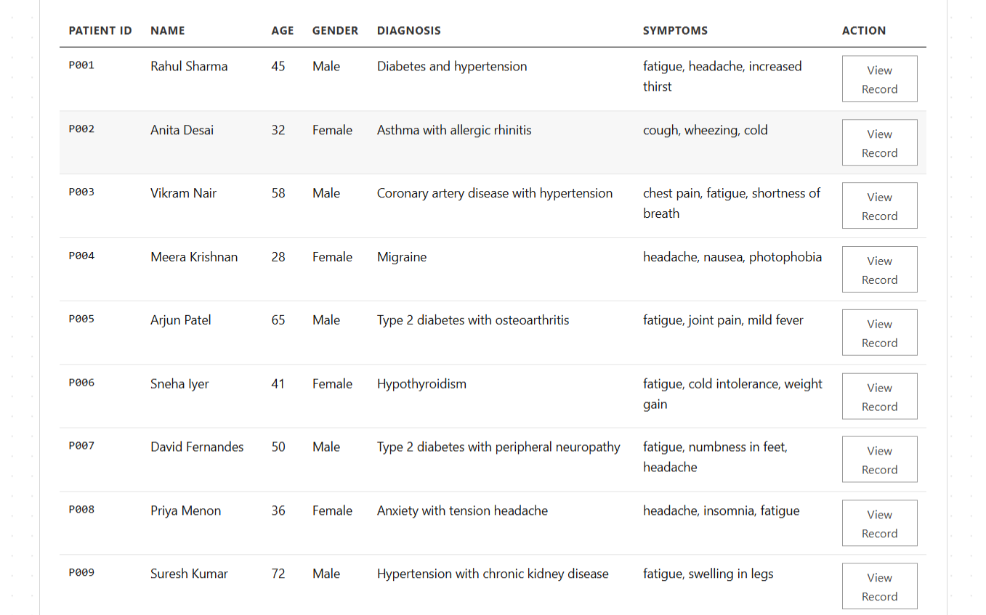
Figure 5.3: Search Interface
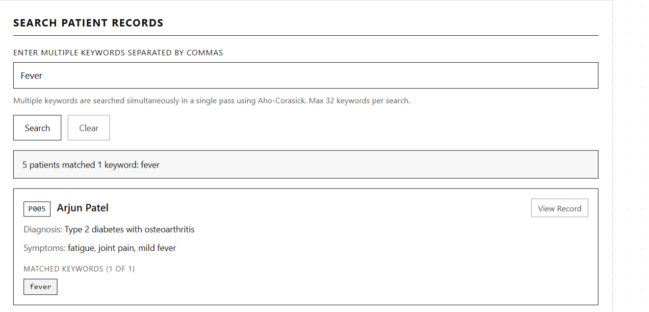

5.4 Test Results
The following test cases can be used to evaluate the implemented functionality.
Test Case | Input | Expected Result | Actual Result | Status
TC01 | Valid login credentials | User successfully logs in | Successfully logged in | Pass
TC02 | Patient records request | Patient records are displayed | Records displayed | Pass
TC03 | Single keyword search | Matching records are returned | Matching records returned | Pass
TC04 | Multiple keyword search | Records containing keywords are returned | Matching records returned | Pass
TC05 | Unknown keyword | No matching records returned | No matching records returned | Pass
TC06 | Empty search input | Request handled without system failure | Input handled | Pass
Important: If any of these behave differently in your actual application, change the “Actual Result” and “Status” accordingly.

5.5 Overall Result
The implemented MediSearch system successfully demonstrates the use of a string-matching algorithm in a practical patient-record retrieval application. The frontend, Java backend, file-based storage, and Aho-Corasick search module work together to retrieve relevant patient records based on user-provided keywords.

6. Challenges & Limitations
6.1 Issues Faced During Development
During development, several challenges were encountered. Integrating the frontend with the Java backend required proper handling of HTTP requests and JSON responses. Another challenge was implementing efficient keyword searching across multiple patient records.
Managing patient data using file-based storage also required careful handling of file reading, writing, and record retrieval. In addition, input validation was necessary to handle invalid, empty, or unmatched search queries without causing errors in the application.
6.2 Solutions Applied
The system was divided into separate modules for the server, services, models, algorithms, and frontend. This made the code easier to organize and maintain.
For multi-keyword searching, the Aho-Corasick algorithm was implemented so that multiple keywords could be processed efficiently in a single search operation. Input validation and basic error handling were also added to improve the reliability of the application.
6.3 Limitations of the System
The current system has the following limitations:
- Patient and user data are stored using files rather than a database.
- The current search implementation uses Aho-Corasick; the other planned algorithms are not yet part of the implemented system.
- The authentication and security mechanisms are basic.
- File-based storage may not scale efficiently for a very large number of patient records.
- The system is designed as an academic project and is not intended for real-world medical diagnosis or treatment.

7. Conclusion & Future Work
7.1 Conclusion
MediSearch demonstrates how Data Structures and Algorithms can be applied to a practical patient-record retrieval problem. The system combines a web frontend, Java backend, file-based storage, and Aho-Corasick-based keyword searching to retrieve relevant patient records.
The project provides practical experience in algorithm implementation, backend development, API communication, file handling, and frontend integration. It also establishes a foundation for extending the system with additional algorithms and improved data-management techniques.
7.2 Future Work
The system can be extended in several ways:
- Implement KMP and Rabin-Karp for additional pattern-searching techniques.
- Add Edit Distance for fuzzy and misspelled keyword searches.
- Add Suffix Array and LCP for text similarity analysis.
- Replace file-based storage with a database.
- Improve authentication and security.
- Add performance benchmarking for different algorithms.
- Improve scalability for larger patient datasets.
- Add advanced filtering and ranking of search results.
7.3 Skills Learned During Development
Through this project, the following skills were developed:
- Data Structures and Algorithms
- Java programming
- String-matching algorithms
- Backend and API development
- HTML, CSS, and JavaScript
- File handling and data management
- Debugging and testing
- Software architecture and modular design
- Technical documentation and project presentation

8. References
Use actual sources you used, for example:
- T. H. Cormen, C. E. Leiserson, R. L. Rivest, and C. Stein, Introduction to Algorithms, MIT Press.
- J. Kleinberg and É. Tardos, Algorithm Design, Pearson.
- A. V. Aho and M. J. Corasick, “Efficient String Matching: An Aid to Bibliographic Search,” Communications of the ACM, 1975.
- Oracle, Java Documentation.
- MDN Web Docs, HTML, CSS and JavaScript Documentation.
- OpenJDK Documentation.
That completes Sections 6, 7, and 8. Your main remaining work is inserting the actual screenshots/test evidence into Section 5 and formatting the whole document consistently.

